THE UNIVERSITY OF HONG KONG
DEPARTMENT OF MATHEMATICS
CCST 5037 Mathematics: A Cultural Heritage
Tutorial 1

Decode the Rhind Papyrus

In this tutorial, we are going to “decode” the Rhind Papyrus. Rhind Papyrus is named after a Scottish antiquarian Alexander Henry Rhind who purchased it in 1858 in Luxor, Egypt. The papyrus dates to around 1650 BCE. The majority of it is now kept in the British Museum.

A. Number system
Most of our knowledge of Egyptian mathematics is derived from the Rhind Papyrus, which contains 85 problems. The mathematics is based on a decimal system of numeration with special signs for each higher decimal unit.
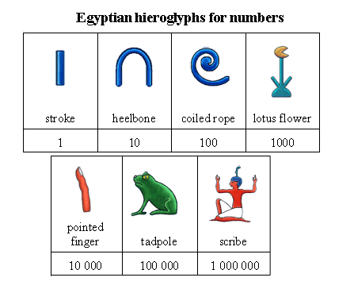
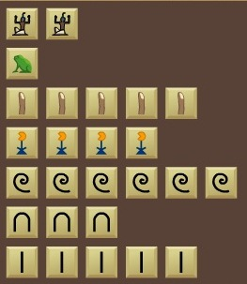
Question 1
- What number does the figure at the right represent?
2154635

- How do the Egyptian people write down the number 246709?

B. Multiplication
On the basis of this system the Egyptians developed an arithmetic of a predominantly additive character, which means that its main tendency was to reduce all multiplication to repeated additions.

For instance, multiplication of 13 by a number was obtained by multiplying the number first by 1, then, using successive doubling 2, then by 4, then by 8, and finally adding the results of the multiplication by 1, 4, and 8 (the components of 13).

1 13
2 26
4 52
8 104
11×13 13+26+104 = 143

Question 2
Can you explain why this method works for integer multiplications?

C. Fractions
The Egyptian placed a mouth above a number to represent the reciprocal of that number. For example, 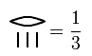 and 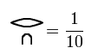.

Another system that the Egyptian used is called the Horus Eye System. Horus Eye is an ancient Egyptian symbol meaning protection, royal power and good health. The system described the reciprocal of the k-th power of 2 where k = 1 to 6.

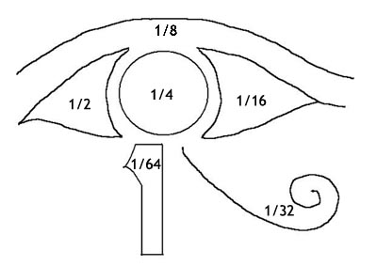
An Egyptian fraction is the sum of distinct unit fractions. Distinct unit fractions means that
1. each fraction in the expression has a numerator equal to 1, and
2. all the denominators are positive integers and are differ from each other.
Every positive rational number can be expressed by an Egyptian fraction. You may prove this if you are interested, but this is not required in this course.

The first part of the Rhind papyrus is taken up by the $\frac{2}{n}$ tables. The fractions $\frac{2}{n}$ for odd n ranging from 5 to 101 are expressed as sums of unit fractions. For example,
$\frac{2}{5}$ = $\frac{1}{3}$ + $\frac{1}{15}$ and $\frac{2}{59}=\frac{1}{36}+\frac{1}{236}+\frac{1}{531}$.
Question 3
a. Can you write $\frac{2}{7}$ and $\frac{2}{9}$ as unit fractions?

b. How did the Egyptian express $\frac{7}{9}$ ?

This is not easy to convert a fraction into the sum of distinct unit fractions. The Egyptian had three methods in doing so. They are Greedy algorithm, continued fractions algorithm and Eye of Horus algorithm.

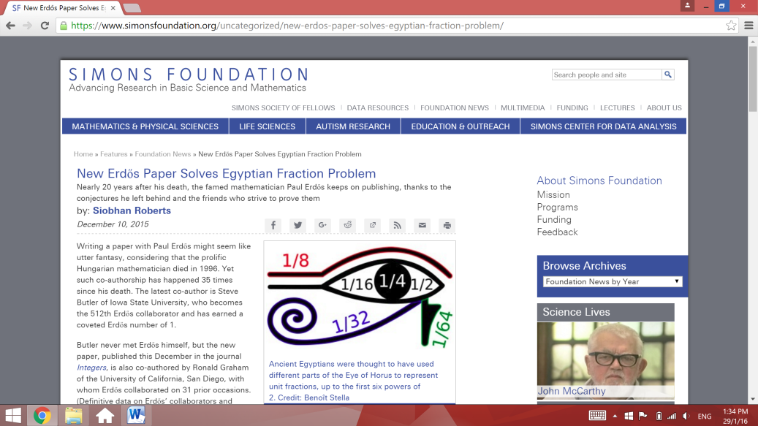
D. Linear Equation with one unknown
Many problems in the Rhind Papyrus were very simple and did not go beyond a linear equation with one unknown. Here is an example:
Problem 31: A quantity, its 2/3, its ½, its 1/7 and itself added together gives 33. What is the quantity?
Can you work out the answer using mathematics that you learned in school?

Answer: $14\frac{28}{97}=14$ $\overline{4}$ $\overline{97}$ $\overline{56}$ $\overline{679}$ $\overline{776}$ $\overline{194}$ $\overline{388}$
E. Arithmetic progression
Problem 40: Dividing 100 loaves among 5 men in such a way that the share received shall be in an arithmetical progression, and that $\frac{1}{7}$ of the sum of the largest three shares shall be equal to the sum of the smallest two. How many loaves does each of them get?

F. Geometric progression
Have you heard the traditional English language nursery rhyme "As I was going to St Ives"?
“As I was going to St Ives
I met a man with seven wives
Every wife had seven sacks
Every sack had seven cats
Every cat had seven kits
Kits, cats, sacks, wives.
How many were going to St Ives?”

Indeed, the origin of the song was one of the problem in the Rhind Papyrus:
Problem 79: There are seven houses; in each house there are seven cats; each cat catches seven mice; each mouse has eaten seven grains of barley; each grain would have produced seven hekat. How many things are mentioned altogether?
Answer: 19607

The latter part of Rhind Papyrus consists of geometry problems. It introduces how to find the volumes of both cylindrical and rectangular based granaries; areas of both circles and octagonal figures; and slopes of pyramids. You may find a lot of references in this topic if you are interested.

